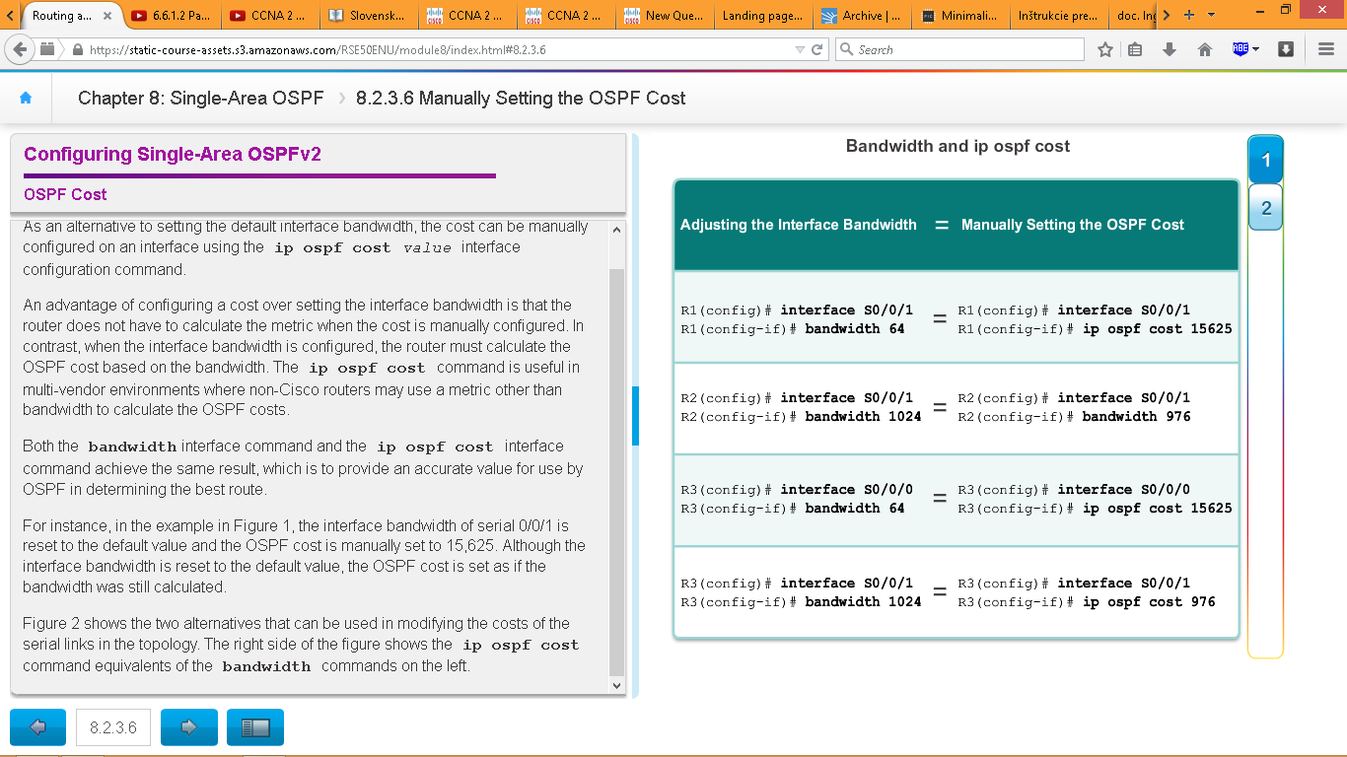

Lällabäpple

Show ip ospf neighbor

Show ip protocols

Show ip ospf

Show ip ospf interface

Show ip ospf interface brief

Show ip ospf interface serial 0/1/0

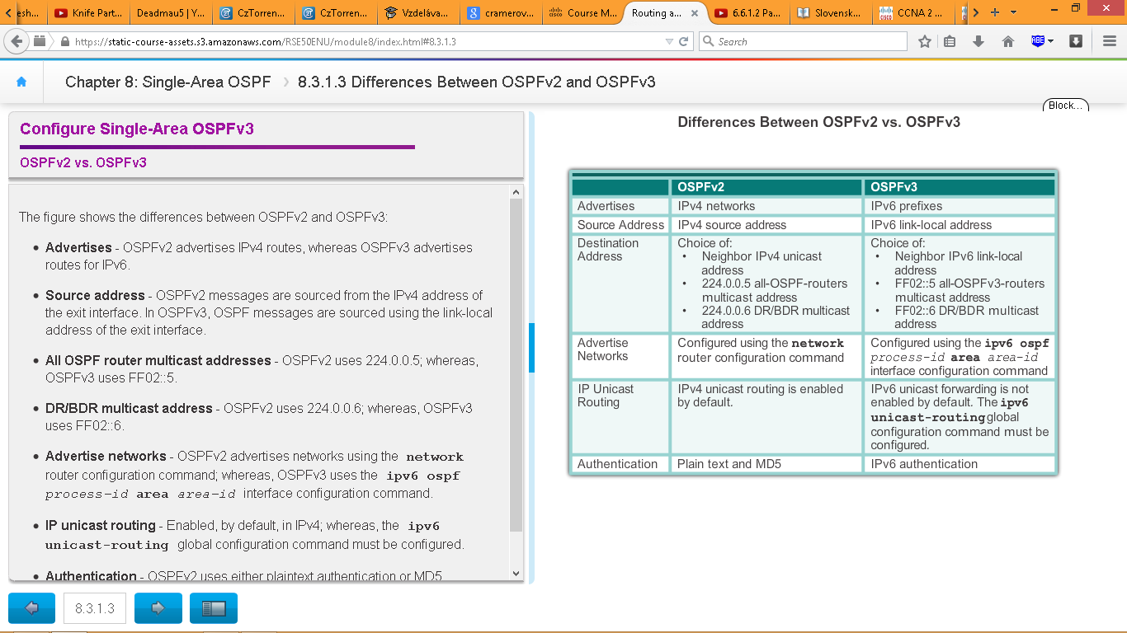

**OSPFv3**

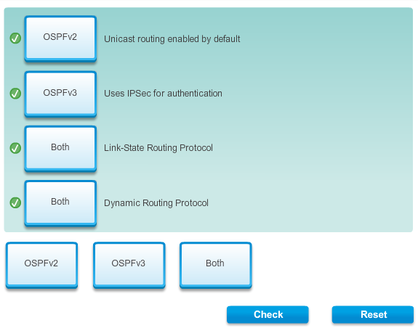

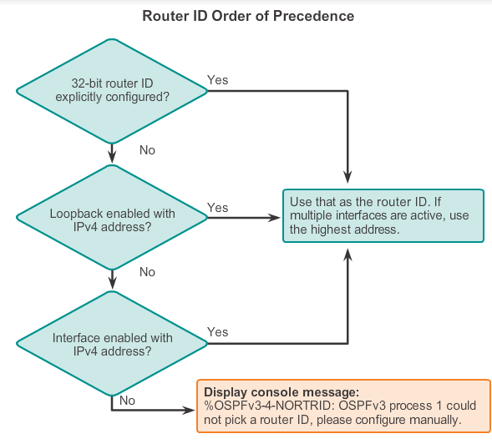

**ipv6 unicast-routing**

Clear ip ospf process

ipv6 ospf *process-id* area ipv6 ospf 10 area 0

**ipv6 router ospf** *process-id*

**show ipv6 ospf neighbor**

**show ipv6 ospf**

**show ipv6 ospf interface**

**show ipv6 ospf interface brief**

**show ipv6 ospf interface serial 0/0/1**

**show ipv6 route ospf**

**show ipv6 protocols -** To quickly verify OSPFv3 configuration information including the OSPF process ID, the router ID, and the interfaces enabled for OSPFv3, you need to issue the command

**show ip protocols -** To quickly verify OSPFv2 configuration information including the OSPF process ID, the router ID, and the interfaces enabled for OSPFv2, you need to issue the command